**0.1 INTRODUZIONE:**

**Soft Whitelist** is a Discord Bot that was born to run automatic Allowlists for FiveM and Red Dead Redemption servers. It will save you time by automating and managing the entire process by asking questions to members.

**0.2 DEFAULT PREFIX** → **!**

**VERSIONS:**

Currently, **3** versions have been launched:

**Lite:** Cheaper version, the Bot is installed with questions and colors already set, not exchangeable.

**Basic**: Intermediate version, the customer has the possibility to choose according to his preferences to make all possible changes, but just 1 time.

(Possible modifications: <https://controlc.com/e3a9033b>).

However, after the first installation it will no longer be possible to change the questions, colors, emojis etc. For each modification you will have to make a request on the Support server, and for each one there will be a slight additional cost.

**PRO**: Advanced version, the user has complete control over the Bot and there are additional systems and commands.

**Any changes that can be made with this version will be explained shortly.**

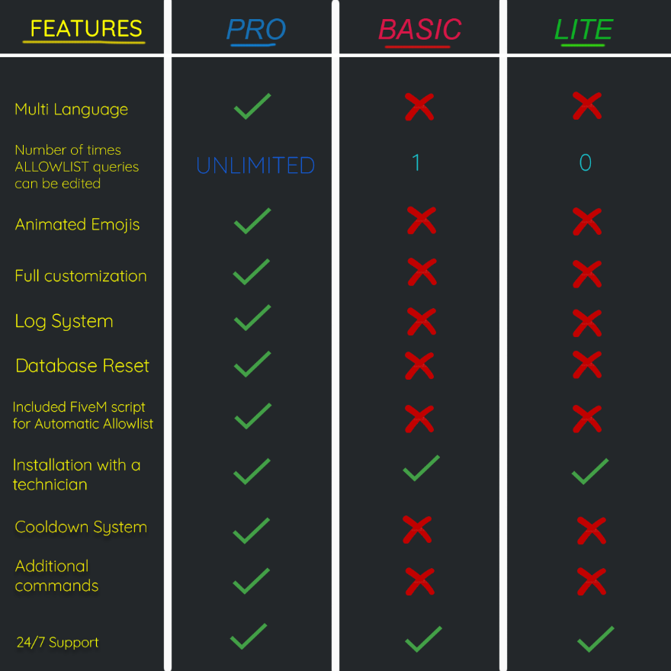

**1.0 COMMANDS:**

**.setup** o .**help**| Basic guide to install the Bot inside the Discord server;

**.commands** | Shows all commands;

**.ping** | Shows the Bot’s ping;

**.prefix** | Shows the Bot’s prefix;

**.createmessage** |Create a message and add a reaction to it from which members will start the Allowlist;

**.setchannel** #channel |Set the channel where the messages from the Bot will arrive to report the members who have passed and have not passed the allowlist, with their respective score and ID.

**.setrole** @Role | Set the role that the Bot will assign to members who pass the Allowlist so that they can join the FiveM server directly.

.**check** @User | Check if the mentioned user is allowlisted;

Please note: Check if the member is in the database of members who passed the Allowlist, not if it has the allowlist role.

**.removeallowlist** @User | Removes the Allowlist from the mentioned member;

**.role** | Shows the currently Allowlist role;

**.resultchannel** | Shows the result channel (set with *!setchannel*)

**.reset** | Reset the Allowlist members database.. (PRO VERSION ONLY)

**.removecooldown** @Member | Removes the member’s Allowlist cooldown. (PRO VERSION ONLY)

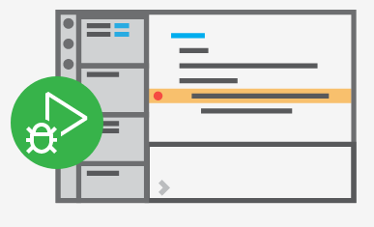**PRO VERSION:**

**The PRO version of Soft Whitelist is the most advanced and efficient version, the following documentation will help in its installation and use.**

**UTILIZZO DEI CONFIG:**

By using two configuration files you will have the ability to change all the parameters of the Bot having complete control.

2.0 **config.json** - configuration file, through it you can change**:**

* 1. Bot prefix;

**2.2** Language;

**2.3** Bot’s token;

**2.4** Response time to Allowlists questions;

**2.5** Minimim amount of correct answers to pass the Allowlist;

**2.6** Minimum amount of characters to insert in the Character Story;

**2.7** Image present in messages;

**2.8** Reaction emoji used to start the Allowlist;

**2.9** Emoji representing the options of the Allowlist questions;

**2.10** Enable or disable status loop of the Bot;

**2.11** Enable or disable only specific states;

**2.12** Abbreviations used in defining the severity of errors and warnings in the Logs;

**2.13** Allowlist’s cooldown time.

3.0 **questions.json** -questions configuration file, we are going to see:

**3.1** How to add a question;

**3.2** How to modify a question;

**3.3** How to delete a question;

**3.4** How can I set less than 4 options?

4.0 Edit the text of the Bot messages and **animated** emojis:

**4.1** How to change the text of the Bot messages;

**4.2** How to change the animated emojis and variables in the Bot messages;

**4.3** Variables that can be used for animated emojis.

Let's look at each field in the **config.json** file in detail:

* **2.1 Bot’s prefix**

The Bot’s default prefix **→ !** However, it can be changed by changing the value of the “bot_prefix” field

← Edit the value inside the quotes to change the Bot prefix

* **2.2 Language**

The Bot’s default language is è **→ it (Italian)**  However, it is not the only language that can be used, at the moment the Bot is available in: Italian and English.

← Edit the value inside the quotes to change the languageo

Values that can be used:

**“it”** ← Italian

**“en”** ← English

In the locales folder you can find the files that contain all the phrases, colors, animated emojis etc. used by the Bot in different languages.

Soon we will see how to change all these parameters by customizing the Bot according to our preferences.

* **2.3 Bot’s token**

The Bot token is a fundamental thing for its execution and is necessary for its functioning.

In summary it consists of a series of characters and it must remain secret and not visible to third parties as whoever is in possession of the token is able to make the Bot execute instructions that could cause significant damage.

To the following page: <https://discord.com/developers/applications> it is possible, by selecting the Bot, to see and generate a new token, in addition to many other functions that are offered.



Token example ↑

* **2.4 Response time to Allowlists questions**

It is possible to set the time in seconds given to a user to answer Allowlist queries.

← Changed the value to the right of the colon, it must be integer and not between quotes.

* **2.5 Minimum amount of correct answers to pass the Allowlist**

Indicates the minimum number of correct answers required to pass the Allowlist.

← Edit the value to the right of the colon, it must be integer and not between quotes.

* **2.6 Minimum amount of characters to insert in the Character Story;**

Indicates the minimum number of characters of the character's RP story that the user must enter when requested.

← Edit the value to the fight of the colon, it must be integer and not between quotes.

* **2.7 Image present in messages**

Some messages, like:

1. The first message that the Bot sends in DM whe a user starts the Allowlist;
2. **!setup** and **!commands**

they do have an image on their right (usually the Bot logo is used) which can be set as follows:

↑ Modifica il valore all’interno dei doppi apici, che deve essere il link di un’immagine generato da discord. Per ottenere un link del genere per la tua immagine devi mandare l’immagine che vuoi usare in un canale di un server Discord o in privato a qualcuno e devi copiare il link dell’immagine che hai appena inviato.

*Example use of this image (this is* ***!commands*** *command)*:

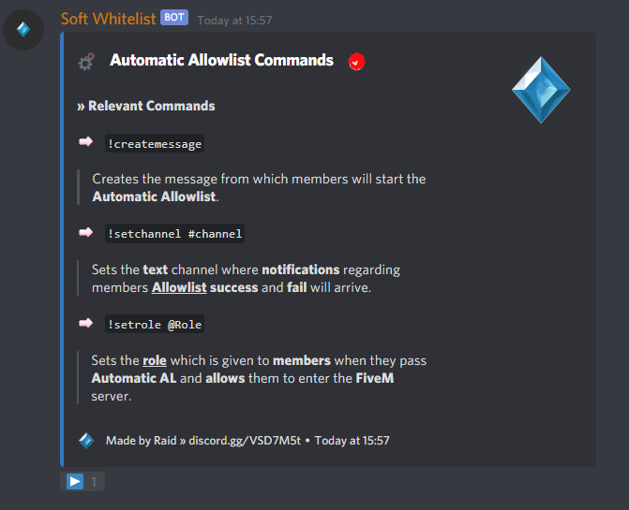

* **2.8 Reaction emoji used to start the Allowlist**

It is the emoji with which members must react to start the Allowlist audition.

It is present in the Allowlist start message (message generated with **!createmessage**)

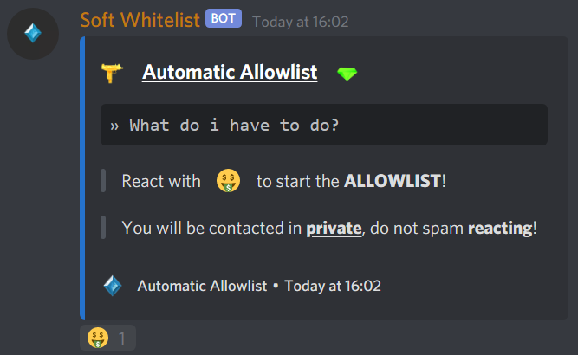**Result:**

****←Insert the emoji between quotes

ATTENTION: Not every emoji may be supported.

Recommended site: <https://emojipedia.org/twitter/>

* **2.9 Emoji representing the options of the Allowlist questions**

They are the emojis with which the user reacts that are used as options to the Allowlist questions.

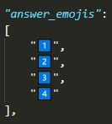

← For each pair of double quotes, enter an emoji. They must be all valued.

**Result:**

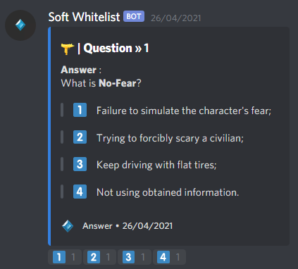

* **2.10 Enable or disable the status loop of the Bot**

What is a Discord status?:



The bot has a system that allows you to view and change the state continuously, more precisely there are 3 states that continue to alternate and can be individually customized and deactivated (we will see shortly how):

1. Status → Watching…
2. Status → Streaming: …
3. Status → Playing…

It is possible to enable or disable the loop status by modifying the "subfield" **enabled** in the "field" **RichPresenceLoop**. It is simpler than it sounds, take a look at the attached image below:

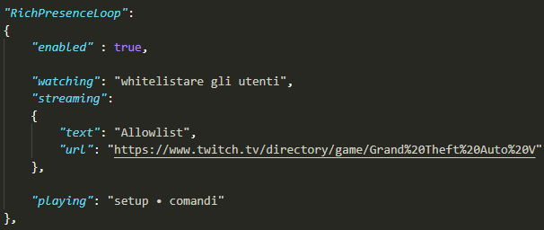

true ← *Activate the status loop*

false ← *Deactivate the status loop*

* **2.11 Enable or disable only specific states**

As previously mentioned, there are basically 3 states that alternate, so it is possible to deactivate them individually. How?

Just remove the content (the writing) in the double quotes, so that the fields are empty. For example, if you want to deactivate the status "He's watching ...":

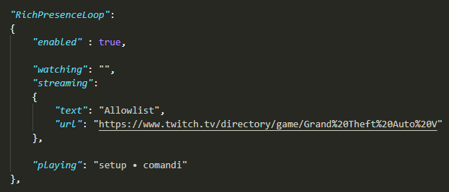

By setting the watching field to “” I deactivated the status “I am watching…”

The same principle applies to the Streaming state: (whose field is streaming) and the I'm playing… state (whose field is playing). All you need to do is delete the content in the double quotes in order to make them "empty".

On the other hand, if you want to display the states again, all you have to do is enter the phrases inside the fields in order to enhance them.

Please note: The streaming status has two fields, the first is the text after the word Streaming: in the status while the other is a URL that redirects to Twitch by clicking the button that is integrated into the Streaming status by twitch.

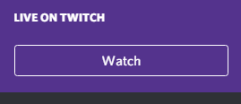

* **2.12 Abbreviations used in defining the severity of errors and warnings in the Logs**

**Soft Whitelist PRO** integrates a **Logs system** that allows you to track problems and errors in order to solve potential vulnerabilities.

In summary, it consists of saving each incorrect instruction (and respective error) in a text file.

These incorrect instructions are represented according to 3 levels of severity:

**CRITICAL, ERROR AND WARNING.**

We will not go into detail but it is enough to know that it is possible to change the name of these 3 abbreviations which are then used in the Logs files.

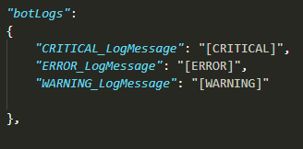

The following abbreviations can be

changed into any word you want.

* **2.13 Changing the Allowist’s cooldown time**

The **PRO** version allows you to put the member in **cooldown** if it does not pass the **Allowlist**. It is possible to change the **time** (in minutes) by entering an integer value in this field:



3.0 **questions.json** -Questions configuration and management file

**PREMISE:**

Along the text concerning the management of questions in the **questions.json** file, the expression "**structure of the question**" will be used. By which we mean the **skeleton** of the question, that is the set of fields concerning the question, the options, the correct answer and also the curly and square brackets.

It is important that the structure of the question within the file is correct in order to make the Bot work correctly.

For each section of question management a video tutorial is linked in case the explanation is not clear enough.

Along the text concerning the management of the questions in the **questions.json** file, the expression "**structure of the question**" will be used. By which we mean the skeleton of the question, that is the set of fields concerning the question, the options, the correct answer and also the curly and square brackets.

It is important that the structure of the question within the file is correct in order to make the Bot work correctly.

For each section of question management a video tutorial is linked in case the explanation is not clear enough.

**EXAMPLE OF A QUESTION STRUCTURE:**

Question

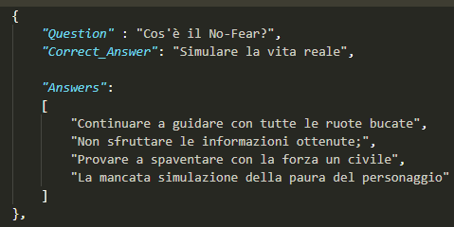

Correct answer, it must be the

same as one of the options

Options

**Every row must end with a comma, except for the last one.**

**If the question is not the last in the file, it must have a comma next to the last brace.**

**3.1** **How to add a question?**

Simple! Go to the **questions.json** file and copy the structure of an existing question, such as the following:

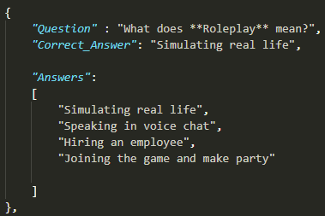

Paste this structure immediately below the structure of the previous question in an aligned way and modify the fields, making sure to enter the values ​​within the "" and ending each line with a comma, except the last one (as shown in the figure).

**BE CAREFUL**:

**There could be 2 situations:**

If the structure you just pasted is the last structure of the file, you will need to remove the comma present in the last brace;

Otherwise, if the structure you pasted is not at the end of the file and therefore is not the last, it must have the comma in its last brace.

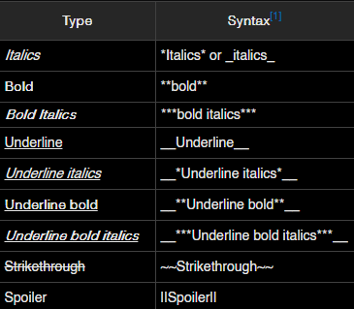**Here’s a video tutorial of the entire process:** [**https://www.youtube.com/watch?v=FcGPKhpZ3KA**](https://www.youtube.com/watch?v=FcGPKhpZ3KA)

**3.2** **How to modify a question?**

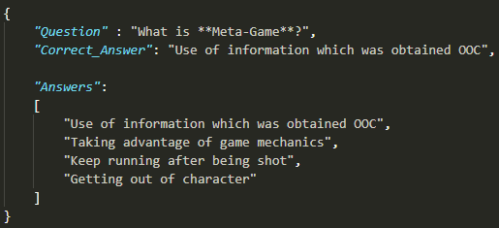Visualize the structure of the question you want to modify, now modify the fields always keeping the values ​​inside the double quotes being careful not to modify the braces and square brackets.

**Here’s a video tutorial of the entire process:** [**https://www.youtube.com/watch?v=60dTQKycdyU**](https://www.youtube.com/watch?v=60dTQKycdyU)

**3.3 How to delete a question?**

Removing a question is very **easy**! Go to the **questions.json** file, visualize the structure of the question you want to delete and **remove it completely**, making sure to also delete its braces and square brackets.

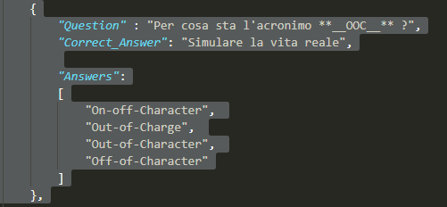

DELETE THE ENTIRE STRUCTURE

**ATTENTION – IF THE QUESTION YOU WANT TO DELETE IS THE LAST ONE**:

**If the question you want to delete is the last one, you must be careful.**

**1:** First step you have to delete the question’s structure,

**2:** After that, the question that is **now** the last will have a **comma** next to its last brace, **delete that** comma.

This is necessary because the last structure of the question cannot end with a comma.

Here’s a video tutorial of the **entire** process: <https://www.youtube.com/watch?v=z3-E_YSdB70>

**3.4 How can i set less than 4 options?**

It is also possible to set questions with 2, 3, or 4 options.

4 Options → You will need to enter all 4 options fields.

3 Options → You will need to enter only the first 3 fields of the options and you will have to set the fourth to “” (empty double quotes)

2 Options → You will need to enter only the first 2 fields of the options and you will have to set the third and the fourth to “” (empty double quotes)

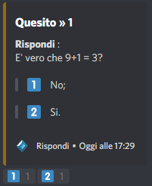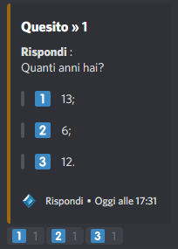

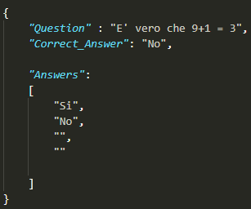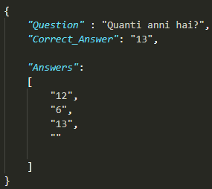

ATTENTION: **The “” (double quotes) MUST not be deleted, only left empty.**

In addition, the fields must be entered in the order described above, not by placing the "" in the middle of the alternatives but by inserting the fields consecutively.

**Please note**: In the examples above the options are in a different order because they have been randomized.

**4.0 How to change the text, colors and animated emojis ?**

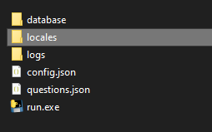If you want to change phrases, colors of the messages, animated emoji etc in the **Allowlist** **system** you have to go to the **locales** **folder** and *select* the file that corresponds to the language you are using.

**4.1 How to change the text of the Bot messages?**

Read the names of the fields (they recall their function) and look for the one that matches the sentence you want to change. At this point, all you have to do is edit the text inside the double quotes, for example:

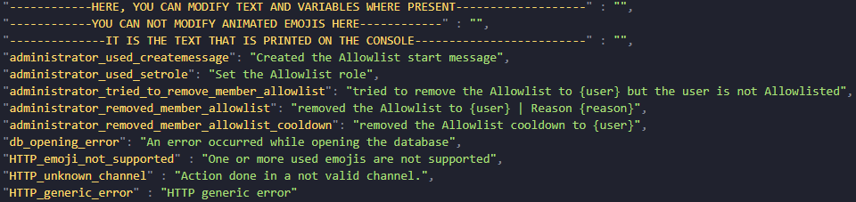

Image link → <https://prnt.sc/127bixd>

Read the lines above the field you want to change:

HERE, YOU CAN MODIFY TEXT AND VARIABLES WHERE PRESENT

YOU CAN NOT MODIFY ANIMATED EMOJIS HERE

IT IS THE TEXT THAT IS PRINTED ON THE CONSOLE

It means that in these fields you can **only** change the text inside the double quotes and you cannot insert animated emojis. These fields contain the text that is displayed in the **terminal** (console) of the Bot.

They are **NOT** the messages that the Bot sends in the Discord channels.

**4.2** **How to change the animated emojis and variables in the Bot messages?**

If you want to **modify**, instead, the text of the messages that the Bot sends in the Discord channels and / or the animated emojis and / or the variables, the **top line** **must** specify that you can modify them, as in example:

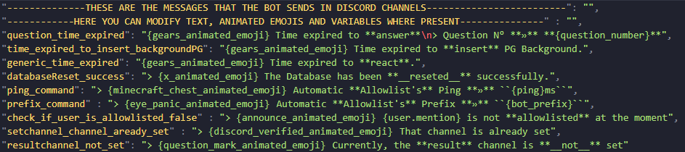

"----------THESE ARE THE MESSAGES THAT THE BOT SENDS IN DISCORD CHANNELS---"

“-----HERE YOU CAN MODIFY TEXT, ANIMATED EMOJIS AND VARIABLES WHERE PRESENT----"

Image link → <https://prnt.sc/127b3cr>

In these fields you can **edit** the text inside the double quotes, and in addition, the words inside the **{}** (curly brackets) are called **VARIABLES**, (summarily) they are words that are **replaced** by values ​​(numeric, text, emoji etc).

It is important to understand, however, that these variables **cannot** be used in any field, you can delete them or use them only in the fields to which they **refer**.

**Exception made for variables corresponding to animated emojis, which can be used in ALL fields below the line**:

HERE YOU CAN MODIFY TEXT, ANIMATED EMOJIS AND VARIABLES WHERE PRESENT

***Variables examples:***

**{ping}** ← It is replaced with the value that corresponds to the Bot's **ping**;

**{bot_prefix}** ← It is replaced with the value that corresponds to the Bot's **prefix**;

**{amount_of_correct_answers}** ← It is replaced with the number of correct responses provided by the member during the Allowlist audition

**{role.mention}** ← It is replaced with the mention of the role.

**4.3** **Variables corresponding to animated emojis:**



| {gears_animated_emoji}

| {beers_animated_emoji}

| {red_verified_animated_emoji}

| {record_spin_animated_femoji}

| {black_and_yellow_verified_animated_emoji}

| {arrow_animated_emoji}

| {question_mark_animated_emoji}

| {minecraft_chest_animated_emoji}

| {looking_around_animated_emoji}

| {awaken_animated_emoji}

| {eye_panic_animated_emoji}

| {greentick_animated_emoji}



| {rainbow_diamond_animated_emoji}

| {awaken_animated_emoji}

| {rainbow_pin_animated_emoji}

| {twitch_bits_animated_emoji}

| {bell_animated_emoji}

| Not available

| Not available

| {discord_loading_animated_emoji}

| {black_verified_animated_emoji}

| {floppy_disk_animated_emoji}

| Not available

| Not available